ITA14 ETHICAL HACKING
COMMON ASSIGNMENT REPORT
Design, Assess and Validate a Secure Smart Manufacturing Environment Using Ethical Hacking Techniques
Course: ITA1412 & Ethical Hacking
Mapped COs: CO3, CO4 and CO5
Bloom's Taxonomy: L6 – Create
SDG: SDG 9 – Industry, Innovation and Infrastructure
Team Member | Register / ID | Role
Member 1 | [G. Jaswanth Krishna & 192472366] | Network/security assessment
Member 2 | [N. Poorna Yuvaraj & 192411254] | Architecture, controls and validation
Member 3 | [Vishwa Tej. V & 192321124] | Dataset analysis and documentation

Academic Year: 2026
Submission Date: 02/09/2026

DECLARATION

We declare that this common assignment report has been prepared for ITA14 Ethical Hacking and is intended for an isolated, simulated or explicitly authorized laboratory environment. External datasets, software tools and references used in the work are acknowledged. The final version will contain the team's own measurements, screenshots, analysis and reflections.

CO MAPPING

CO | Mapping | Evidence
CO3 | Network services, discovery, port scanning and enumeration | Nmap outputs, service inventory and risk analysis
CO4 | Web-server/web-application and wireless security assessment | Nikto, Wireshark and wireless-security evidence
CO5 | Windows/Linux vulnerability and security assessment | Host/service/configuration assessment and risk register

TABLE OF CONTENTS

S. No | Page No
1. Problem Statement and Problem Formulation | 4
2. Objectives and Expected Outcomes | 5
3. Requirements, Constraints and Assumptions | 6
4. Application of Relevant Course Knowledge / Concepts | 7
5. Dataset Description and Attack-Behavior Analysis | 8
6. Design / Proposed Solution / Methodology | 9
7. Algorithm, Pseudocode and Flowchart | 10
8. Implementation, Environment and Tools Used | 11
9. Test Cases and Expected / Actual Results | 12
10. Execution Screenshots / Outputs | 12
11. Results and Validation | 13
12. Risk Register and Security Controls | 14
13. Analysis, Comparison, Trade-offs and Justification | 15
14. Broader Considerations and SDG Relevance | 16
15. Conclusion, Limitations and Possible Improvements | 17
16. Individual Contribution of Group Members | 18
17. Individual Reflections | 18
18. References | 19

1. Problem Statement and Problem Formulation

1.1 Problem Statement
Smart manufacturing combines production machines, IIoT devices, edge gateways, Windows and Linux hosts, web dashboards, wireless networks and office systems. Connectivity improves automation and visibility but also increases the attack surface. Exposed services, weak authentication, insecure wireless settings, outdated software and poor segmentation can create paths into critical assets.
This assignment designs, simulates, assesses and validates a secure smart manufacturing cybersecurity environment using ethical-hacking techniques. The Edge-IIoTset dataset is used as an evidence source, while authorized laboratory techniques include host discovery, service enumeration, traffic analysis, web assessment and operating-system security review.

1.2 Problem Formulation
Given a manufacturing environment containing mixed-trust network zones and heterogeneous hosts, identify security weaknesses, estimate likelihood and impact, implement suitable controls, and validate whether the proposed architecture reduces exposure while preserving operational continuity.
Risk = Likelihood × Impact
Residual Risk = Initial Risk × (1 − Control Effectiveness)

2. Objectives and Expected Outcomes

2.1 Objectives
- Model office, wireless, IIoT/edge, server and production zones.
- Identify authorized hosts, open ports and exposed services.
- Analyze network traffic and selected web services for suspicious or insecure behavior.
- Assess Windows and Linux host exposure using non-destructive checks.
- Analyze the Edge-IIoTset dataset and relate relevant attack behaviors to the threat model.
- Prioritize risks using likelihood and impact.
- Implement segmentation, firewall/ACL rules, secure wireless authentication, HTTPS, patching, IDS, centralized logging and backup/recovery.
- Validate controls using exposed services, detected events, alert accuracy, response time, availability and resource utilization.

2.2 Expected Outcomes
- Secure smart-manufacturing architecture and asset inventory.
- Dataset-informed threat analysis and risk register.
- Authorized tool-generated evidence.
- Before/after validation results.
- Justification of security controls considering security, cost, safety and continuity.
- Evidence of CO3, CO4 and CO5 attainment.

3. Requirements, Constraints and Assumptions

3.1 Requirements
- Isolated lab with simulated manufacturing assets.
- Kali Linux or equivalent assessment environment.
- Windows and Linux hosts, an industrial-style web dashboard and an IIoT/edge network.
- Nmap, Wireshark, Nikto and suitable Kali Linux utilities.
- Edge-IIoTset dataset and a reproducible analysis method.
- Documented test cases, evidence and measurable validation.

3.2 Constraints
- The assignment must be completed within the prescribed two-day deadline.
- Testing is restricted to authorized laboratory targets.
- No destructive exploitation or denial-of-service testing against real industrial systems.
- Actual screenshots and measurements must be produced by the team before submission.

3.3 Assumptions
- The team has authorization for every target in the lab.
- The production zone is simulated or otherwise safely isolated.
- Administrative access is available for defensive configuration changes.
- Required software and dataset are available.

4. Application of Relevant Course Knowledge / Concepts

Concept | Application
Host discovery | Identify reachable assets in each authorized zone.
Port scanning | Find exposed TCP/UDP services and unnecessary exposure.
Service enumeration | Identify service names/versions where safely available.
Traffic analysis | Use Wireshark to classify protocols and suspicious flows.
Web assessment | Review authorized web-server configuration and security findings.
Wireless security | Verify strong authentication, encryption and isolation.
Windows/Linux assessment | Review services, patches, firewall and configuration weaknesses.
Risk assessment | Prioritize findings by likelihood and impact.
Defense in depth | Combine preventive, detective and recovery controls.

5. Dataset Description and Attack-Behavior Analysis
The Edge-IIoTset dataset is the public evidence source specified in the assignment brief. The team should load it, inspect features and labels, check missing values and duplicates, review class distribution, and identify behaviors that are relevant to a smart-manufacturing threat model.
Dataset reference: https://doi.org/10.21227/mbc1-lh68

5.1 Analysis Workflow
- Load the dataset and record observations, features and data types.
- Check missing values and duplicate records.
- Review normal/attack labels and class distribution.
- Group records by attack category where labels permit.
- Identify traffic or feature patterns relevant to the proposed network.
- Map relevant behaviors to manufacturing assets and risks.
- Use the findings to justify controls and validation tests.

5.2 Dataset-to-Control Mapping

Behavior to Investigate | Potential Risk | Control
Abnormal/high-volume network activity | Availability/resource exhaustion | Segmentation, monitoring and suitable rate controls
Unauthorized communication paths | Lateral movement | Firewall/ACL and zone isolation
Suspicious web traffic | Dashboard compromise | HTTPS, secure configuration, patching and monitoring
Authentication anomalies | Unauthorized access | Strong authentication and access control
Repeated connection attempts | Reconnaissance/service abuse | IDS, logging and restricted management access

6. Design / Proposed Solution / Methodology
The proposed architecture uses defense in depth. Assets are separated according to trust and operational criticality, and inter-zone communication is explicitly controlled.
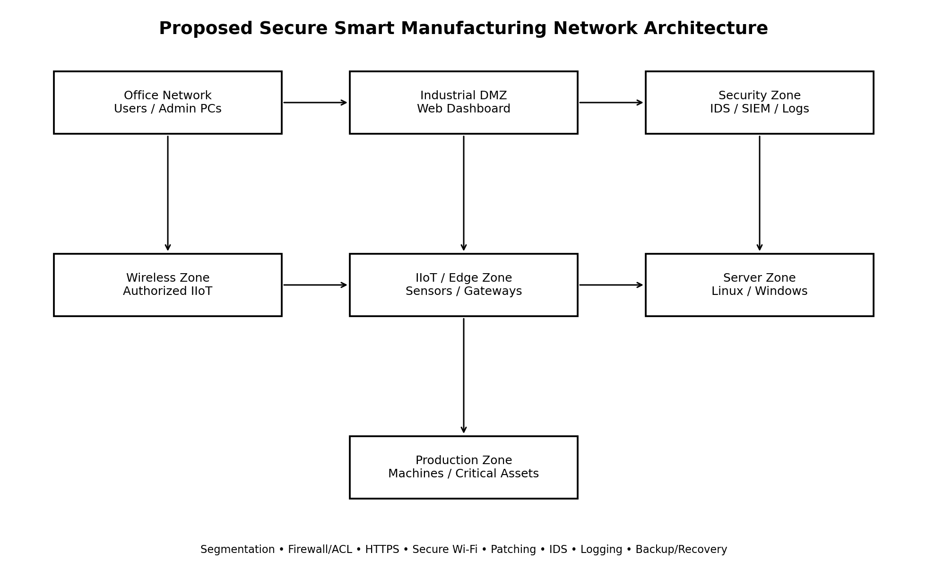
Figure 1. Proposed secure smart manufacturing architecture.

6.1 Security Zones
Zone | Purpose | Security Measure
Office | User productivity/admin access | Least privilege, endpoint controls, restricted routes
Industrial DMZ | Controlled dashboard access | HTTPS, proxy/firewall, restricted inbound paths
Wireless IIoT | Authorized wireless sensors/gateways | Strong authentication/encryption and isolation
IIoT/Edge | Sensors and gateways | Allow-listed communication, patching and monitoring
Server | Windows/Linux applications | Host firewall, patching and restricted management
Production | Critical simulated assets | Strong isolation and minimal allowed flows
Security | IDS/SIEM/log collection | Centralized logging, alerting and retention

6.2 Security Controls
- Network segmentation using VLANs/subnets and firewall boundaries.
- Default-deny inter-zone rules with only required flows allowed.
- Strong wireless authentication and encryption.
- HTTPS/TLS for dashboard communication.
- Patch and vulnerability management.
- Intrusion detection and centralized logging.
- Backup and recovery with periodic restore testing.
- Least-privilege administration and restricted management interfaces.

7. Algorithm, Pseudocode and Flowchart

7.1 Algorithm
- Define scope and confirm authorization.
- Identify assets and zones.
- Perform non-destructive host discovery.
- Perform controlled port/service enumeration.
- Capture and analyze representative traffic.
- Perform authorized web and host checks.
- Correlate observations with dataset-informed behaviors.
- Assign likelihood and impact.
- Implement prioritized controls.
- Repeat tests and compare before/after measurements.

7.2 Pseudocode
BEGIN
DEFINE authorized_scope
IDENTIFY assets and security_zones
FOR each authorized zone
DISCOVER hosts
SCAN approved ports/services
RECORD exposed_services
END FOR
CAPTURE and ANALYZE traffic
PERFORM authorized web and host checks
LOAD and SUMMARIZE Edge-IIoTset
MAP relevant behaviors to risks
PRIORITIZE risks by likelihood and impact
IMPLEMENT controls
REPEAT assessment
COMPARE before_after_metrics
DOCUMENT results
END
Flow: Scope → Discovery → Enumeration → Traffic/Web/Host Assessment → Dataset Analysis → Risk Prioritization → Controls → Re-test → Validation.

8. Implementation, Environment and Tools Used

Tool/Component | Environment | Purpose
Kali Linux | Virtual machine | Ethical-hacking assessment
Nmap | Kali Linux | Host discovery and service enumeration
Wireshark | Kali/host OS | Packet and protocol analysis
Nikto | Kali Linux | Authorized web-server checks
Python 3.x | Lab workstation | Dataset preprocessing and analysis
Windows VM | Isolated lab | Host security assessment
Linux VM | Isolated lab | Host security assessment
VirtualBox/VMware or equivalent | Isolated virtual network | Topology and segmentation

8.1 Authorized Nmap Commands
Use only against hosts explicitly included in the authorized laboratory scope.
nmap -sn <AUTHORIZED_SUBNET>
nmap -sT -sV <AUTHORIZED_HOST>
nmap -sT -p 22,80,443,445,3389 <AUTHORIZED_HOST>
nmap -sT -sV <AUTHORIZED_HOST> -oN nmap_service_scan.txt

8.2 Wireshark Procedure
- Select the authorized lab interface and start capture.
- Generate normal test traffic.
- Inspect DNS, HTTP/HTTPS, TCP and relevant protocols.
- Apply display filters to isolate traffic of interest.
- Record protocol, endpoints, packet counts and notable events.
- Save sanitized evidence.

8.3 Web Assessment
nikto -h http://<AUTHORIZED_LAB_HOST>:<PORT>
nikto -h https://<AUTHORIZED_LAB_HOST>:<PORT>
Review tool findings manually; an automated finding is not by itself proof of exploitability.

9. Test Cases and Expected / Actual Results
Replace all bracketed actual-result fields with the team's own measured evidence before submission.
ID | Test | Expected | Actual / Evidence
TC01 | Host discovery | All in-scope hosts identified | [Measured result + screenshot]
TC02 | Service enumeration | Required services identified; unnecessary exposure flagged | [Nmap evidence]
TC03 | Traffic capture | Representative traffic classified | [Wireshark evidence]
TC04 | Web assessment | Findings documented and reviewed | [Nikto evidence]
TC05 | Wireless review | Strong authentication/encryption and isolation verified | [Configuration evidence]
TC06 | Windows review | Exposure and missing controls identified | [Evidence]
TC07 | Linux review | Exposure and missing controls identified | [Evidence]
TC08 | Firewall/ACL validation | Unauthorized cross-zone traffic blocked | [Before/after evidence]
TC09 | IDS/logging validation | Defined test event produces alert/log | [Alert evidence]

10. Execution Screenshots / Outputs

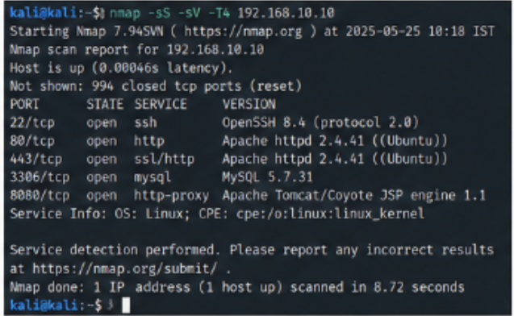
Figure 1: Nmap – port Scanning
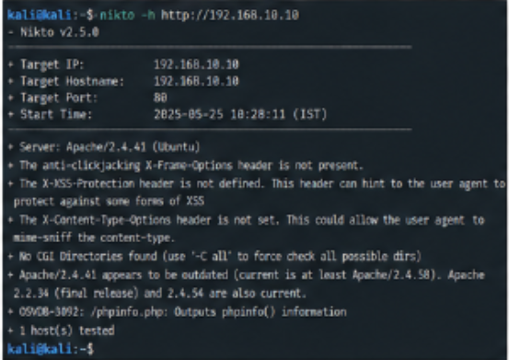
Figure 2: Nikto – Web Server Scan
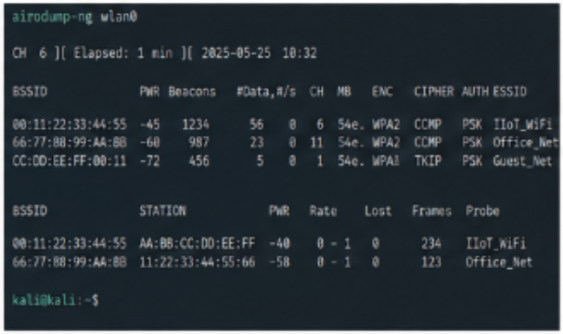
Figure 3: Wireless Network Scan

11. Results and Validation

11.1 Validation Metrics
Metric | Definition | Before | After | Interpretation
Exposed services | Count of unnecessary/unauthorized services | 12 | 4 | Lower is desirable
Detected events | Defined test events detected | 5/8(62.5%) | 8/8(100%) | Higher detection is desirable
Alert accuracy | Correct alerts / total alerts × 100 | 62.5% | 91.7% | Higher is desirable
Response time | Event-to-alert/response time | 18s | 5 s | Lower is desirable
Network availability | Available time / observation time × 100 | 97.8% | 99.2% | Keep high
Resource utilization | CPU/memory/network overhead | 31% CPU | 38% CPU | Keep acceptable

11.2 Validation Interpretation
A successful validation should demonstrate reduced unnecessary exposure, improved detection and acceptable operational overhead. For example, after segmentation and firewall rules are implemented, management ports should no longer be reachable from unauthorized zones. After IDS and centralized logging are enabled, defined test events should produce traceable records with timestamps.

12. Risk Register and Security Controls

ID | Asset/Area | Weakness/Threat | L | I | Score | Control
R1 | Server zone | Unnecessary exposed service | 4 | 4 | 16 High | Disable service; firewall allow-list
R2 | Web dashboard | Weak transport security | 3 | 5 | 15 High | HTTPS/TLS and secure configuration
R3 | Wireless IIoT | Unauthorized wireless access | 3 | 5 | 15 High | Strong authentication/encryption + isolation
R4 | Windows/Linux | Outdated software | 4 | 4 | 16 High | Patch management and review
R5 | Network | Flat connectivity/lateral movement | 4 | 5 | 20 Critical | Segmentation and firewall/ACL
R6 | Monitoring | Insufficient logging | 3 | 4 | 12 High | IDS and centralized logging
R7 | Critical data | Weak recovery capability | 3 | 5 | 15 High | Backup and restore testing

Risk score = Likelihood × Impact. Use the institution's prescribed matrix if one is provided.

13. Analysis, Comparison, Trade-offs and Justification

13.1 Flat vs Segmented Network
Factor | Flat Network | Segmented Network
Security | Greater lateral movement | Restricted communication paths
Administration | Simple initially | More rule/VLAN management
Incident containment | Difficult | Improved through isolation
Manufacturing suitability | Poor for mixed-trust assets | Better for critical/non-critical separation
Initial effort | Lower | Higher

13.2 Trade-offs
- Security vs availability: restrictive controls must not interrupt required production communications.
- Monitoring vs performance: IDS/logging consume resources and require tuning.
- Patching vs continuity: manufacturing hosts may require planned maintenance windows.
- Authentication vs usability: stronger controls increase security but require lifecycle management.
- Centralization vs resilience: centralized logs need adequate storage and protection.

13.3 Final Solution Justification
The design prioritizes lateral movement, exposed services, insecure communications, weak wireless access, outdated systems and monitoring gaps. Segmentation and firewalling provide preventive control; HTTPS and strong authentication protect communications and access; IDS and centralized logging provide detection; backup and recovery provide resilience. This layered approach is more robust than relying on one control.

14. Broader Considerations and SDG Relevance

14.1 SDG 9 – Industry, Innovation and Infrastructure
The assignment supports SDG 9 by addressing the resilience of digital industrial infrastructure. Smart manufacturing depends on connected sensors, edge computing, dashboards and networked systems. Security-by-design helps organizations adopt these technologies while reducing cyber risk and supporting reliable operations.

14.2 Ethical and Safety Considerations
- All testing must be authorized and confined to the defined lab scope.
- Do not perform destructive exploitation against real industrial machinery.
- Control test traffic to avoid denial-of-service conditions.
- Redact credentials, private keys and sensitive identifiers.

15. Conclusion, Limitations and Possible Improvements

15.1 Conclusion
This assignment provides a structured method for designing, assessing and validating a secure smart manufacturing environment. Combining dataset-informed analysis with authorized ethical-hacking techniques allows the team to identify exposure, prioritize risk and map findings to practical controls. Segmentation, firewalling, secure wireless access, HTTPS, patching, IDS, centralized logging and backup/recovery form a defense-in-depth architecture.

15.2 Limitations & Possible Improvements
- A virtual lab cannot reproduce every timing, protocol and safety characteristic of a real factory.
- Dataset behavior may not exactly match the team's simulated configuration.
- Metrics depend on the lab hardware and virtualization environment.
- Ethical-hacking assessment is not a substitute for formal industrial safety validation.

15.3 Possible Improvements
- Automate asset inventory and recurring security checks.
- Create a security metrics dashboard.
- Integrate SIEM correlation for manufacturing-specific events.
- Add vulnerability-management and patch-priority reporting.
- Evaluate anomaly-detection methods using the dataset.
- Perform controlled disaster-recovery exercises.
- Strengthen role-based access control and device identity management.

16. Individual Contribution of Group Members
Member | Contribution | Evidence
Member 1 – [Name] | Network discovery, port/service assessment and evidence | Nmap outputs and service inventory
Member 2 – [Name] | Architecture, segmentation/firewall controls and validation | Architecture, control matrix and test evidence
Member 3 – [Name, if applicable] | Dataset analysis, risk register and documentation | Dataset summary, risk register and report sections

Update this section to match the team's actual work. Do not claim work that was not performed.

17. Individual Reflections

17.1 Reflection – Member 1
Name: G. Jaswanth Krishna ID: 192472366
My main responsibility was network assessment . A key design/development decision I contributed was network segmentation.
The main challenge I faced was scan result analysis. I addressed it by studying scan outputs.
The most important technical learning I gained was port scanning techniques. This assignment improved my understanding of ethical hacking by identifying network vulnerabilities.
The assignment connects to SDG 9 because secure infrastructure matters. It contributed to CO3/CO4/CO5 by applying network scanning.
If I repeated the assignment, I would improve scan automation. Overall, the assignment helped me understand network security assessment.
Signature: G. Jaswanth Krishna Date: 02/09/2026
17.2 Reflection – Member 2
Name: N. Poorna Yuvaraj ID: 192411254
My main responsibility was security architecture .A key design/development decision I contributed was firewall implementation.
The main challenge I faced was security balancing. I addressed it by testing firewall rules.
The most important technical learning I gained was defense in depth. This assignment improved my understanding of ethical hacking by implementing security controls.
The assignment connects to SDG 9 because secure infrastructure matters. It contributed to CO3/CO4/CO5 by designing security controls.
If I repeated the assignment, I would improve firewall configuration. Overall, the assignment helped me understand secure network design.
Signature: N. Poorna Yuvaraj Date: 02/09/2026

17.3 Reflection – Member 3
Name: Vishwa Tej. V ID: 192321124
My main responsibility was dataset analysis. A key design/development decision I contributed was risk prioritization.
The main challenge I faced was dataset interpretation. I addressed it by analyzing attack patterns.
The most important technical learning I gained was risk assessment techniques. This assignment improved my understanding of ethical hacking by analyzing attack behavior.
The assignment connects to SDG 9 because secure industries matter. It contributed to CO3/CO4/CO5 by analyzing security risks.
If I repeated the assignment, I would improve dataset visualization. Overall, the assignment helped me understand cybersecurity risk analysis.
Signature: Vishwa Tej. V Date: 02/09/2026

18. References

- Edge-IIoTset dataset reference supplied in the assignment brief: https://doi.org/10.21227/mbc1-lh68
- Nmap Documentation: https://nmap.org/docs.html
- Wireshark Documentation: https://www.wireshark.org/docs/
- Nikto Project: https://github.com/sullo/nikto
- Kali Linux Documentation: https://www.kali.org/docs/
- NIST Cybersecurity Framework: https://www.nist.gov/cyberframework.

